Artur Pas  **⋅** Rzeszów, Polska  **⋅** [pasartur108@gmail.com](mailto:pasartur108@gmail.com)  **⋅** +48 727 763 000

Artur Pas CV

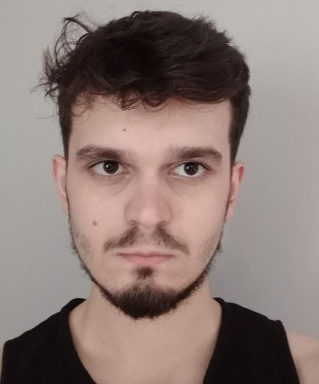

|  |  |
| --- | --- |
| * **Status:** | Computer Science student: 2nd year at Uniwersytet Rzeszowski |
| * **Tech:** | HTML, CSS , JS, PHP, SQL, C, Java, Python, WolframMathematica |
| * **Languages:** | Polish – native, English – B2 |
| * **Loves:** | Gaming, Programming, Self-development, Problem solving |

I hereby give consent for my personal data included in my application to be processed for the purposes of the recruitment process under the European Parliament’s and Council of the European Union Regulation on the Protection of Natural Persons as of 27 April 2016, with regard to the processing of personal data and on the free movement of such data, and repealing Directive 95/46/EC (Data Protection Directive)

**E.12 – Montage and ekspolatation of personal computers and peripheral devices**

**E.13 – Designing computer networks and network administration**

**E.14 – Creation of internet applications and databases and database administration**

* **Certificates**

|  |  |  |
| --- | --- | --- |
| **2021 - NOW** | **Computer Science** | **Uniwersytet Rzeszowski** |
|  | * Java * Wolfram Mathematica |  |

|  |  |  |
| --- | --- | --- |
| **2020 - 2021** | **Computer Science** | **Politechnika Rzeszowska im. Ignacego Łukasiewicza** |
|  | * C * Python * Electical Circuits |  |

|  |  |  |
| --- | --- | --- |
| **2016 - 2020** | **Computer Science** | **Zespół Szkół Technicznych im. Bohaterów Września 1939 r. w Kolbuszowej** |
|  | * Creating basic web applications * MySql database management * Networks administration * Operating systems administration * Build of a personal computer |  |

* **Education**

|  |  |  |
| --- | --- | --- |
| **2018** | **Apprenticeship** | **Brammer S.A. Kolbuszowa** |

* **Experience**

I am a second-year student of Computer Science at Uniwersytet Rzeszowski. I graduated from the technical school with the computer science specialization. During my high school studies, I did a month-long apprenticeship.

I am interested in programming, because I enjoy creating things and solving problems. I am also interested in computer games and learning languages. You can see my projects on [my webiste](https://pas-artur.000webhostapp.com/) or on [github](https://github.com/Pasek108).

* **Profile**